Concept of a Matrix
A matrix is a rectangular array of numbers or other mathematical objects, for which operations such as addition and multiplication are defined. Matrices are used to represent and solve linear equations, perform transformations in space, and model various physical, biological, and engineering systems.

Notation
A matrix is usually denoted by a capital letter (e.g., A) and its elements are denoted by lowercase letters with two subscripts (e.g., a_{ij}​), where the first subscript denotes the row and the second subscript denotes the column of the element.
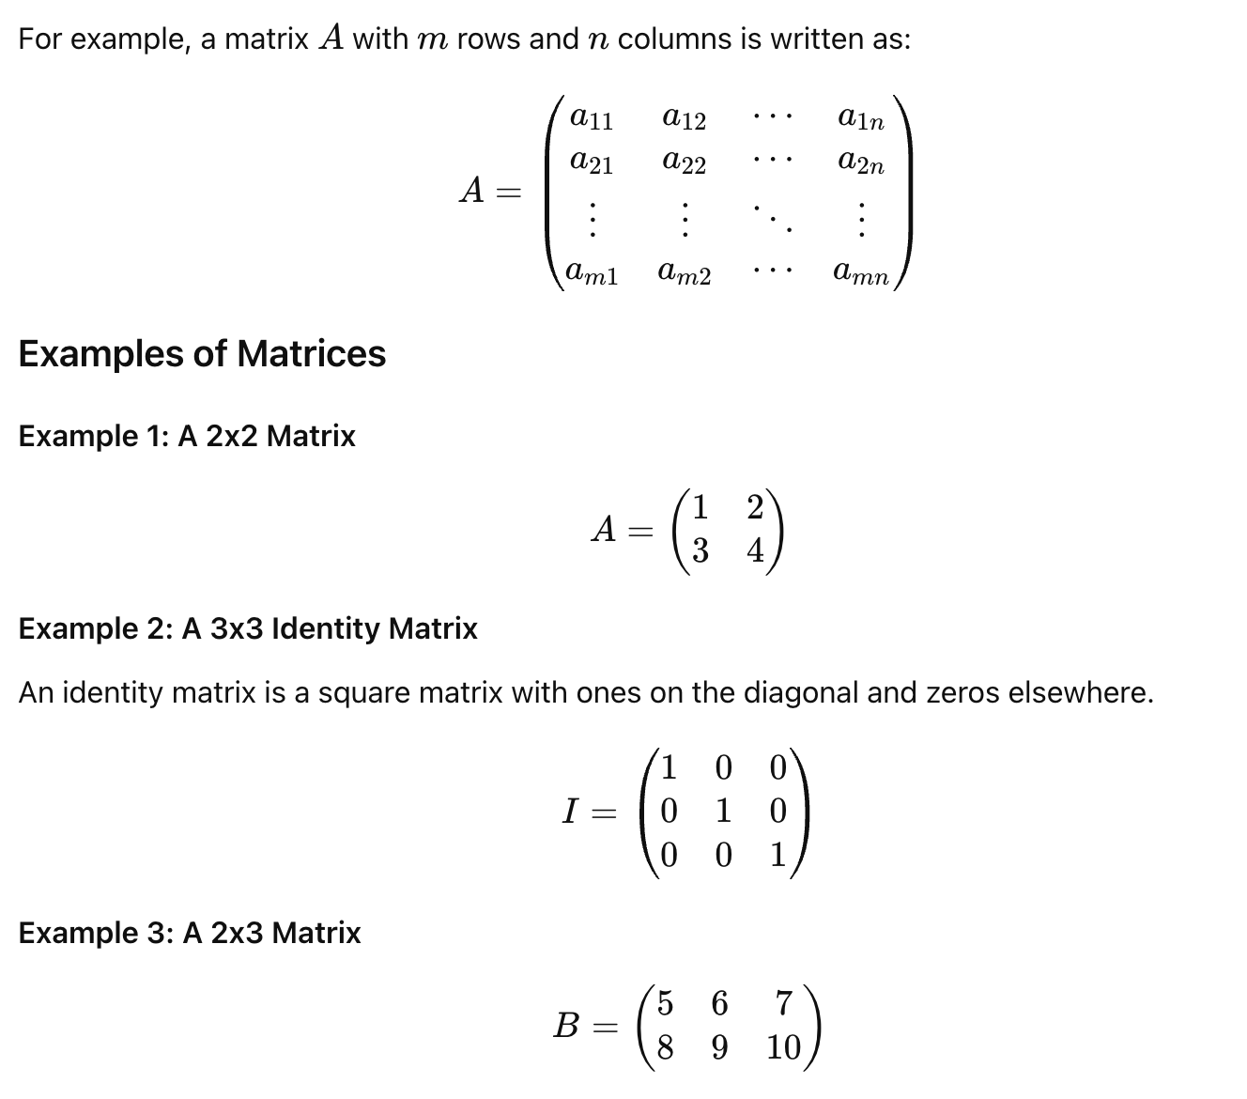

Operations on Matrices

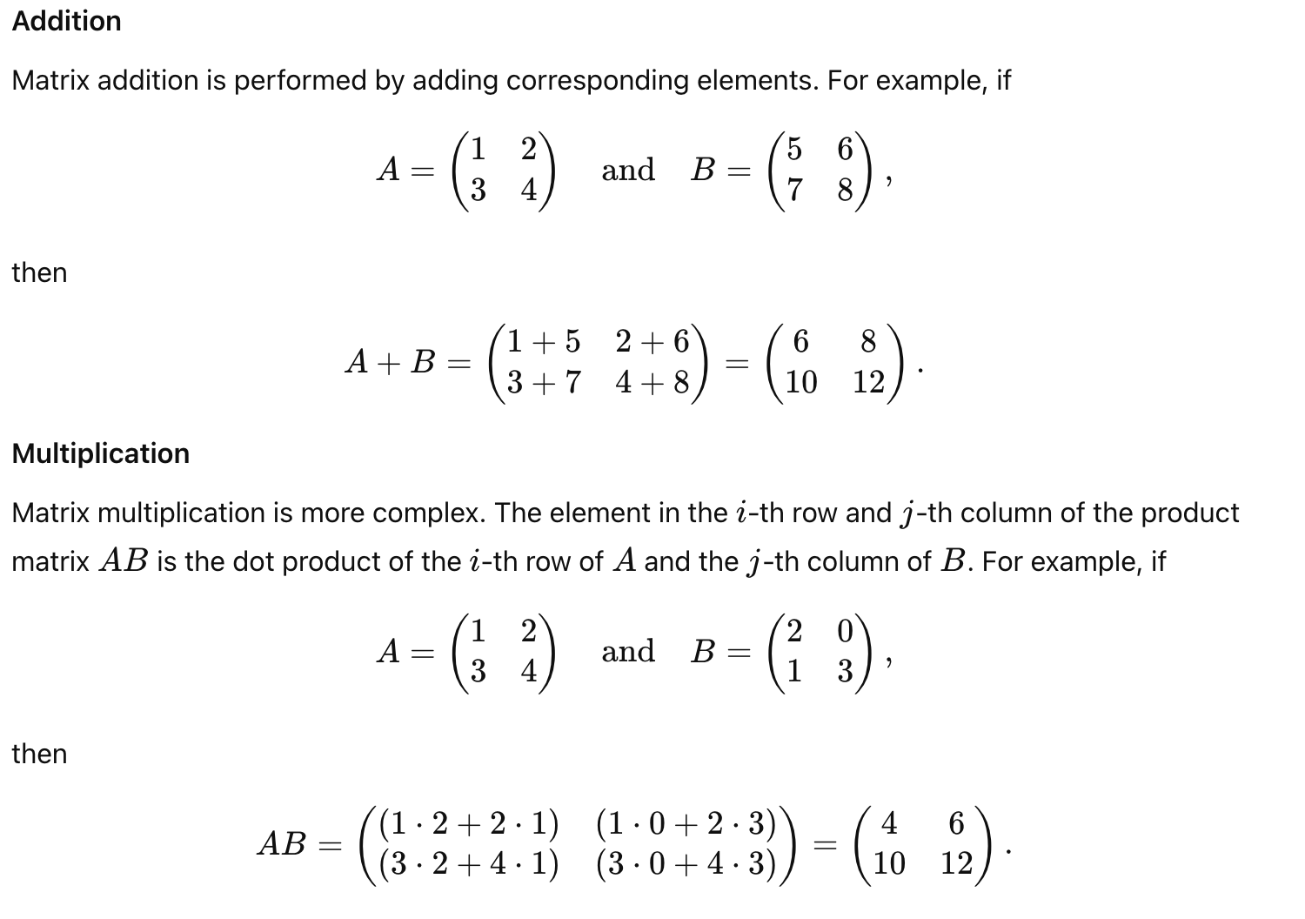

Definitions and Examples in Matrix Algebra

Definitions
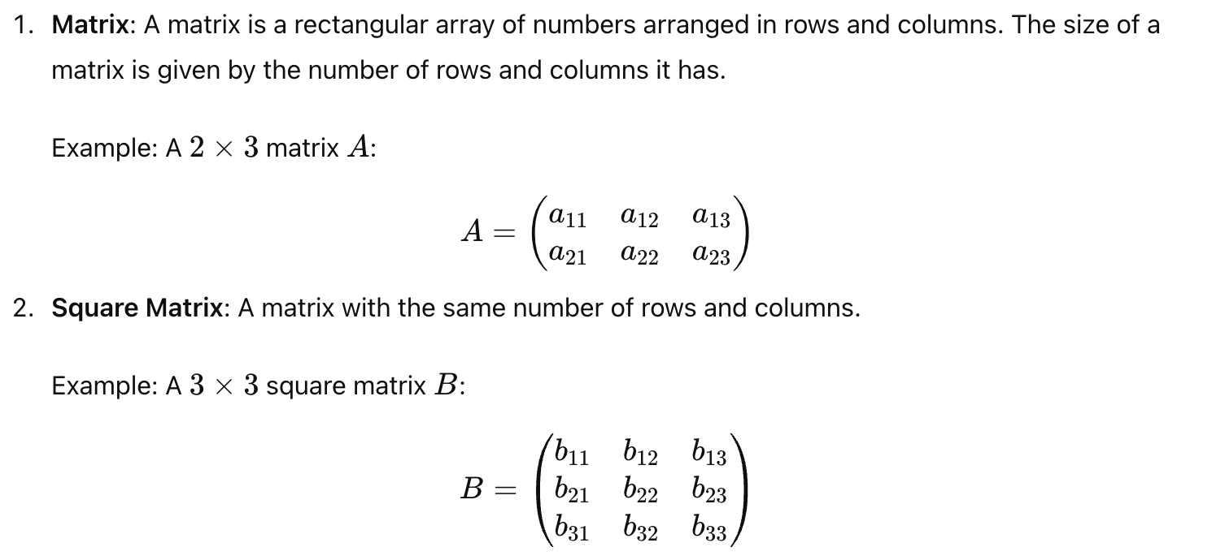

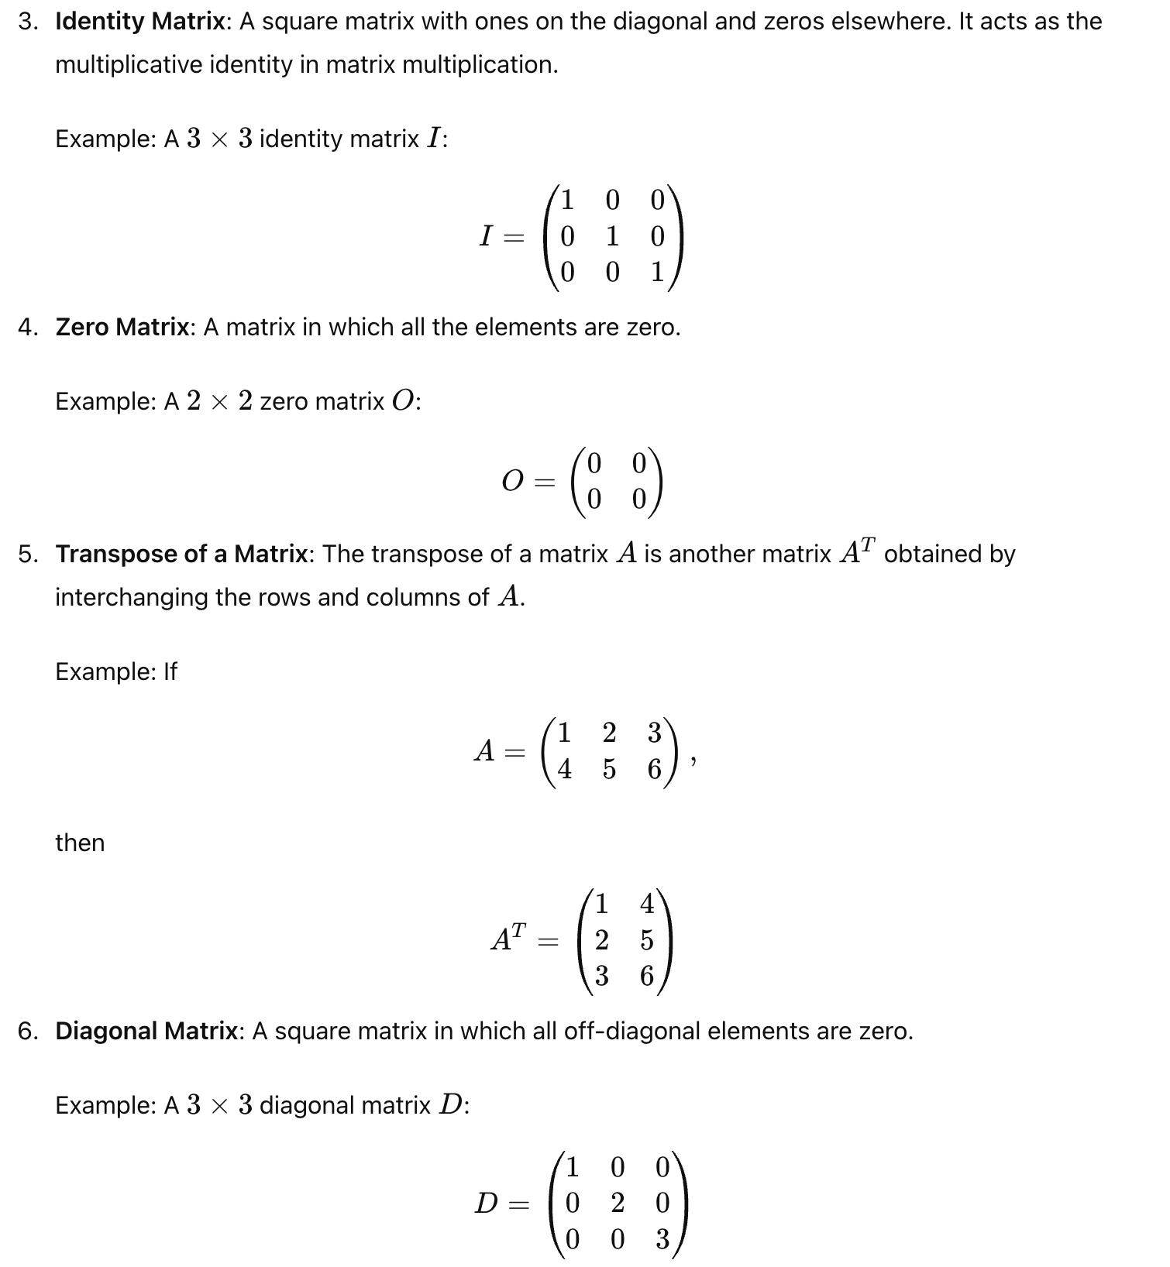

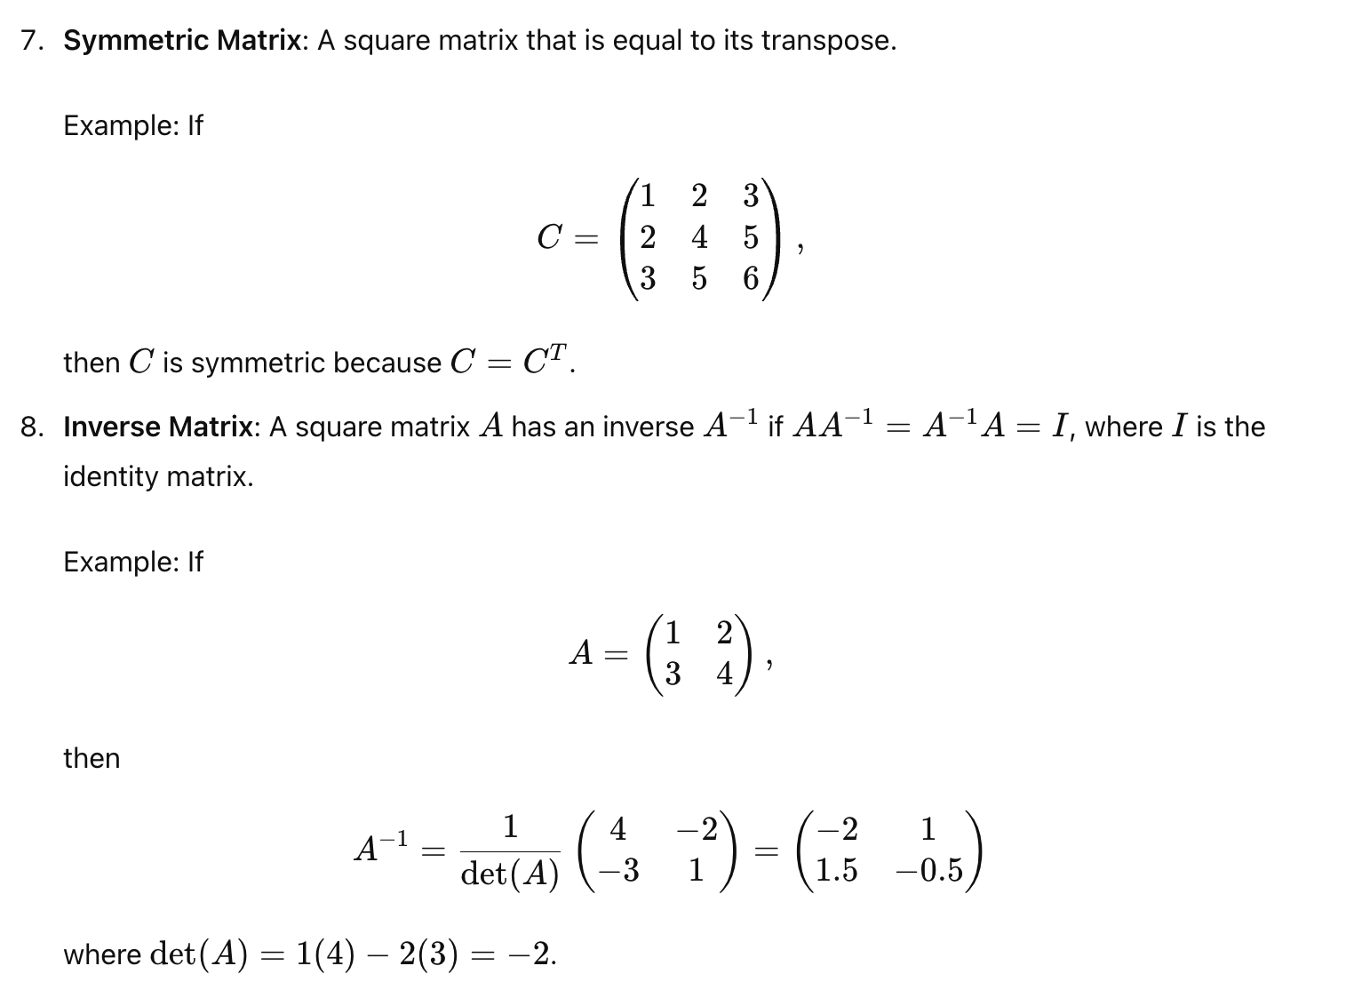
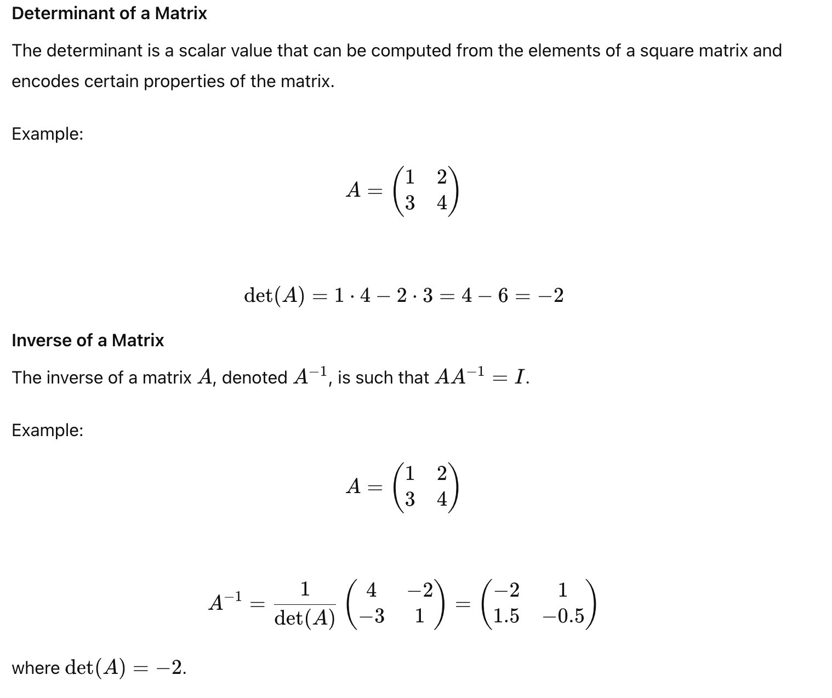

Applications of Matrices
- Solving Systems of Linear Equations: Matrices are used to represent systems of linear equations. The augmented matrix method and matrix inversion are common techniques.
- Computer Graphics: Matrices are used to perform linear transformations such as rotation, scaling, and translation on objects.
- Data Science: Matrices are fundamental in data representation, especially in machine learning and statistics, where data is often represented as matrices.
- Physics and Engineering: Matrices are used in various fields to model physical systems, electrical circuits, and more.

